**TOPIC-6**



You have an Azure subscription that contains a storage account named storage1 in the North

Europe Azure region.  
  
You need to ensure that when blob data is added to storage1, a secondary copy is created in the East US region. The solution must minimize administrative effort.  
  
What should you configure?

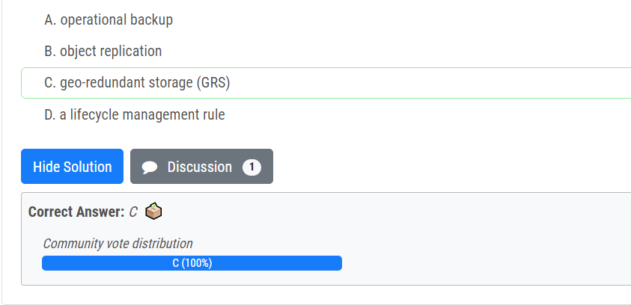



You have an Azure subscription that contains two Log Analytics workspaces named Workspace1 and Workspace2 and 100 virtual machines that run Windows Server.  
  
You need to collect performance data and events from the virtual machines. The solution must meet the following requirements:  
  
• Logs must be sent to Workspace1 and Workspace 2.  
• All Windows events must be captured.  
• All security events must be captured.  
  
What should you install and configure on each virtual machine?

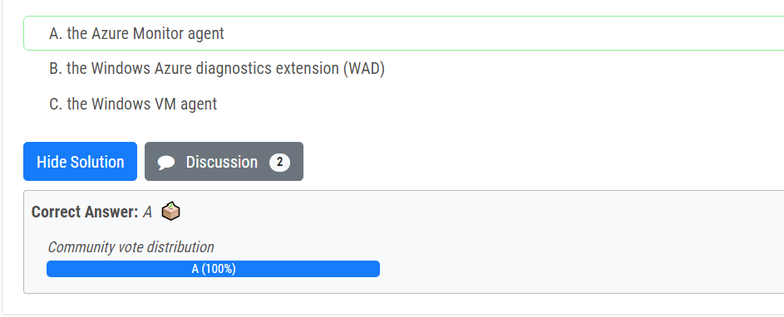



You have an Azure subscription that contains a virtual machine named VM1 and an Azure function named App1.  
  
You need to create an alert rule that will run App1 if VM1 stops.  
  
What should you create for the alert rule?

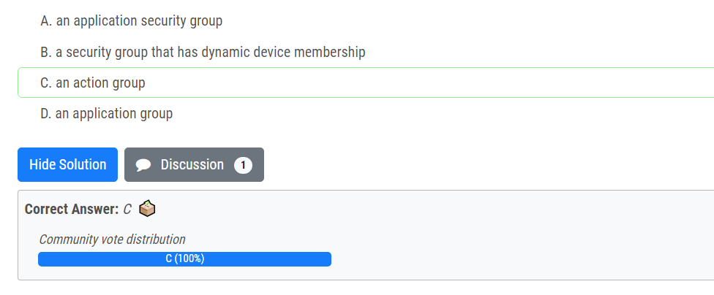



You have an Azure subscription that contains a virtual network named VNet1.  
  
VNet1 uses two ExpressRoute circuits that connect to two separate on-premises datacenters.  
  
You need to create a dashboard to display detailed metrics and a visual representation of the network topology.  
  
What should you use?

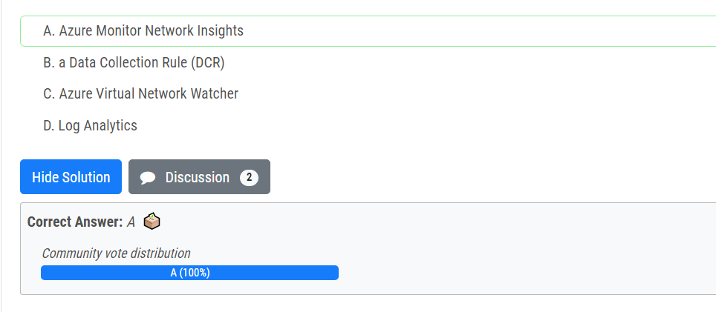



You deploy Azure virtual machines to three Azure regions  
  
each region contains a virtual network. Each virtual network contains multiple subnets peered in a full mesh topology.  
  
Each subnet contains a network security group (NSG) that has defined rules.  
  
A user reports that he cannot use port 33000 to connect from a virtual machine in one region to a virtual machine in another region.  
  
Which two options can you use to diagnose the issue? Each correct answer presents a complete solution.  
  
NOTE: Each correct selection is worth one point.

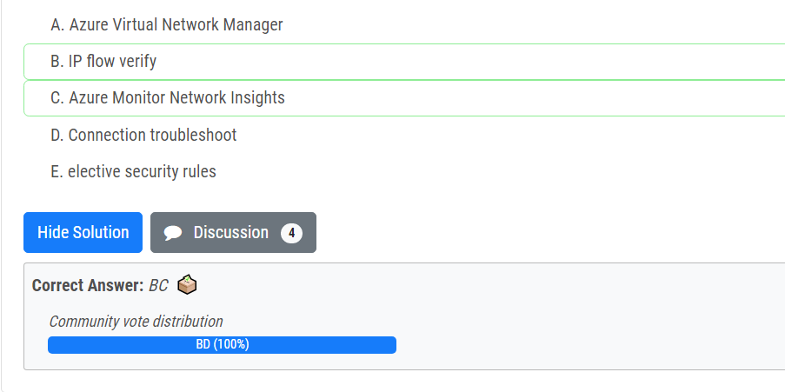

**TOPIC-2**



You have an Azure subscription named Subscription1 that contains a virtual network named VNet1. VNet1 is in a resource group named RG1.  
  
Subscription1 has a user named User1. User1 has the following roles:  
  
• Reader  
• Security Admin  
• Security Reader  
  
You need to ensure that User1 can assign the Reader role for VNet1 to other users.  
  
What should you do?

* A. Assign User1 the Network Contributor role for VNet1.
* B. Remove User1 from the Security Reader role for Subscription1. Assign User1 the Contributor role for RG1.
* C. Assign User1 the Owner role for VNet1.
* D. Assign User1 the Network Contributor role for RG1.

**Correct Answer:** *C*



You have an Azure subscription that contains the users shown in the following table.

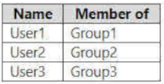

The groups are configured as shown in the following table.

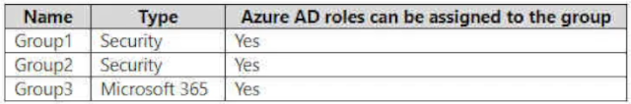

You have a resource group named RG1 as shown in the following exhibit.

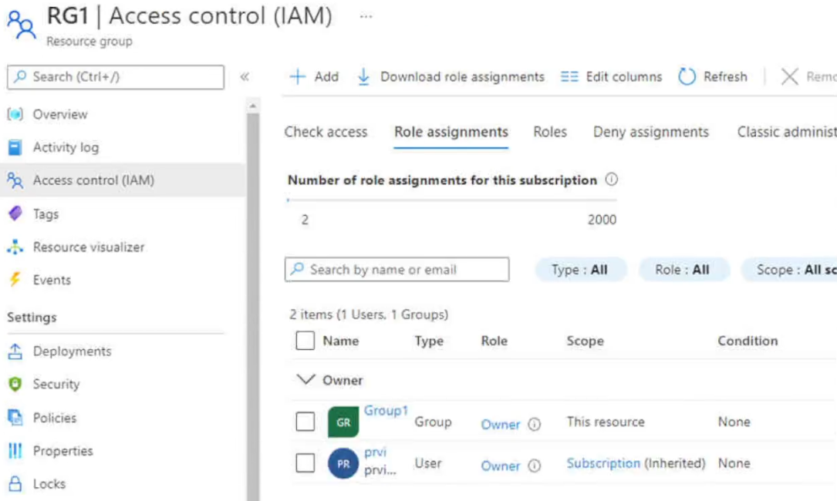

For each of the following statements, select Yes if the statement is true. Otherwise, select No.

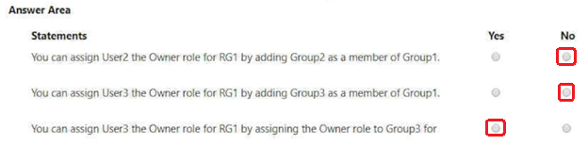

Nested group is not supported in AZure AD roles but it’s supported in Azure RBAC.

**TOPIC-3**



You have an Azure subscription that contains a user named User1 and a storage account named storage1. The storage1 account contains the resources shown in the following table.

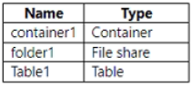 User1 is assigned the following roles for storage1:  
  
• Storage Blob Data Reader  
• Storage Table Data Contributor  
• Storage File Data SMB Share Contributor  
  
For storage1, you create a shared access signature (SAS) named SAS1 that has the settings shown in the following exhibit. (Click the Exhibit tab.)

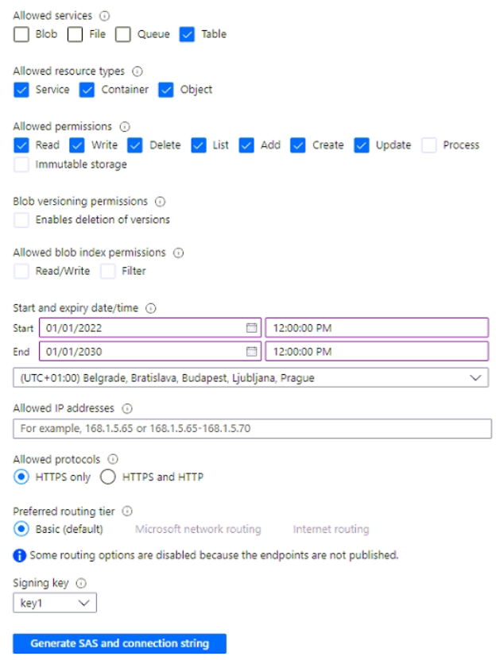

To which resources can User1 write by using SAS1 and key1? To answer, select the appropriate options in the answer area.

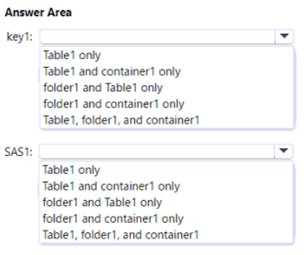



You have an Azure subscription that contains the storage account shown in the following exhibit.

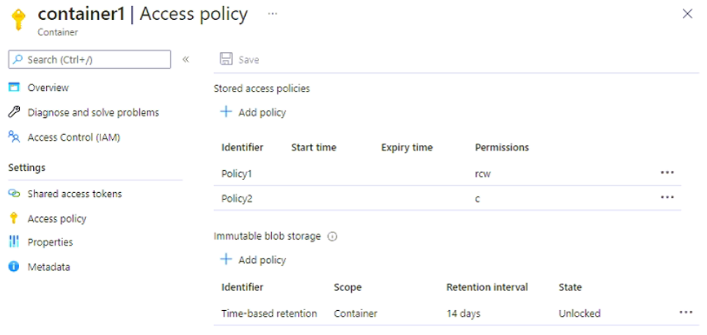

Use the drop-down menus to select the answer choice that completes each statement based on the information presented in the graphic

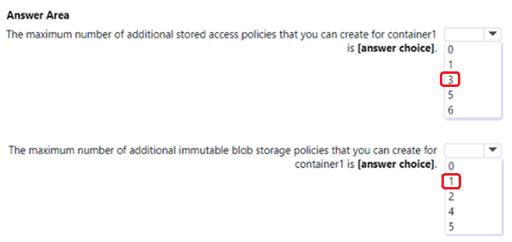

Max stored access policies: 3 (because max total of stored access policy is 5 and we already have 2, so additional 3 available).

Max immutable blob storage: 1(because max total of immutable blob storage policy is 2 - one Legal hold policy and one Time-based retention policy. We already have one, so additional 1 available).



You have an Azure subscription. The subscription contains a storage account named storage1 that has the lifecycle management rules shown in the following table.

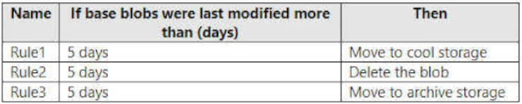

On June 1, you store a blob named File1 in the Hot access tier of storage1.

What is the state of File1 on June 7?

* A. stored in the Cool access tier
* B. stored in the Archive access tier
* C. stored in the Hot access tier
* D. deleted

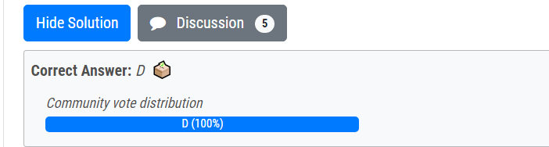



You have an Azure subscription that contains the storage accounts shown in the following table.

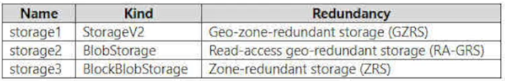

You need to identify which storage accounts support lifecycle management, and which storage accounts support moving data to the Archive access tier.  
  
Which storage accounts should you use? To answer, select the appropriate options in the answer area.

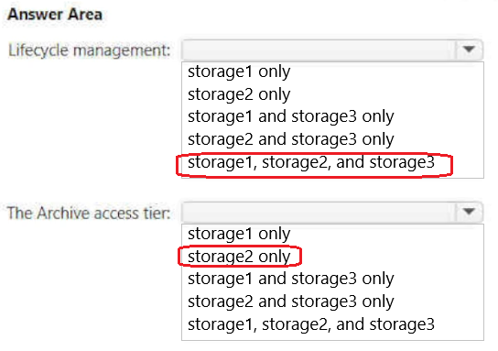

1 - storage1, storage2, storage3

Lifecycle management policies are supported for block blobs and append blobs in general-purpose v2, premium block blob, and Blob Storage accounts.

2 - storage2

Only storage accounts that are configured for LRS, GRS, or RA-GRS support moving blobs to the archive tier. The archive tier isn't supported for ZRS, GZRS, or RA-GZRS accounts.

**TOPIC-4**



You have an Azure subscription.  
  
You plan to deploy the Azure container instances shown in the following table.

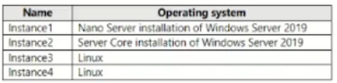

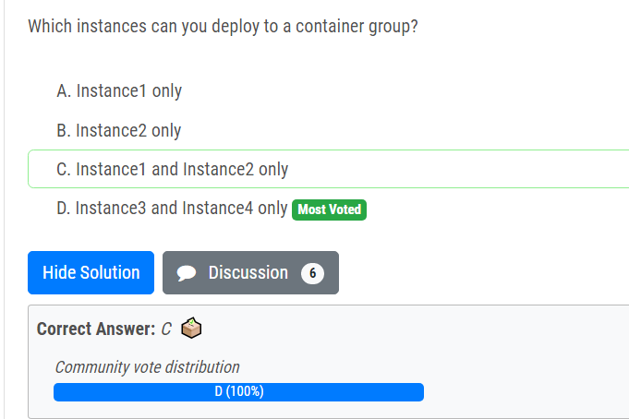

**TOPIC-5**



You have an Azure subscription that contains the resources shown in the following table.

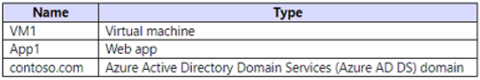

All the resources connect to a virtual network named VNet1.  
  
You plan to deploy an Azure Bastion host named Bastion1 to VNet1.  
  
Which resources can be protected by using Bastion1?

* A. VM1 only
* B. contoso.com only
* C. App1 and contoso.com only
* D. VM1 and contoso.com only
* E. VM1, App1, and contoso.com

